**Assignment – 3**

**Financial Analytics**

**TITLE :** Analyzing competitive advantage in real companies

**CONTENT**

* Introduction
* Background
* Competitive advantage
* Financial performance evaluation
* Comparative analysis
* Assessment of sustainability
* Conclusion

In this task I am analysing the competitive advantage of two real companies operating in different industries. One company from technology sector i.e. **SAMSUNG** and another from the consumer goods sector ie.. INDIAN TOBACCO COMPANY LIMITED-**ITC**

**INTRODUCTION**

* **COMPANY FROM TECHNOLOGY SECTOR :** **SAMSUNG INC**

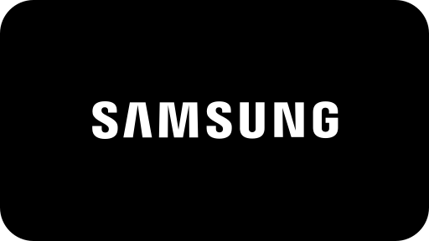

**SAMSUNG**

is a South Korean [multinational](https://en.wikipedia.org/wiki/Multinational_corporation) manufacturing [conglomerate](https://en.wikipedia.org/wiki/Conglomerate_(company)) headquartered in Samsung Digital City, [Suwon](https://en.wikipedia.org/wiki/Suwon), South Korea. It comprises numerous affiliated businesses, most of them united under the Samsung brand, and is the largest South Korean [*chaebol*](https://en.wikipedia.org/wiki/Chaebol) (business conglomerate). As of 2020, Samsung has the eighth-highest global [brand value](https://en.wikipedia.org/wiki/Brand_valuation).

Samsung was founded by [Lee Byung-chul](https://en.wikipedia.org/wiki/Lee_Byung-chul) in 1938 as a [trading company](https://en.wikipedia.org/wiki/Trading_company). Over the next three decades, the group diversified into areas including food processing, textiles, insurance, securities, and retail. Samsung entered the [electronics industry](https://en.wikipedia.org/wiki/Electronics_industry) in the late 1960s and the construction and shipbuilding industries in the mid-1970s; these areas would drive its subsequent growth. Following Lee's death in 1987, Samsung was separated into five business groups – Samsung Group, [Shinsegae](https://en.wikipedia.org/wiki/Shinsegae) Group, [CJ Group](https://en.wikipedia.org/wiki/CJ_Group) and [Hansol](https://en.wikipedia.org/wiki/Hansol) Group, and [JoongAng](https://en.wikipedia.org/wiki/JoongAng_Ilbo) Group.

* **COMPANY FROM CONSUMER GOODS SECTOR** : **INDIAN TOBACCO COMPANY LIMITED**

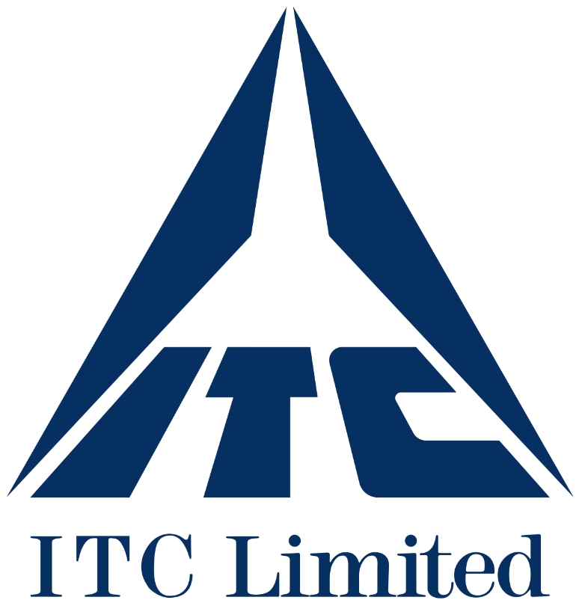

**ITC Limited** is an Indian [conglomerate company](https://en.wikipedia.org/wiki/Conglomerate_company) headquartered in [Kolkata](https://en.wikipedia.org/wiki/Kolkata). ITC has a diversified presence across industries such as [FMCG](https://en.wikipedia.org/wiki/Fast-moving_consumer_goods), [hotels](https://en.wikipedia.org/wiki/Hotel), [software](https://en.wikipedia.org/wiki/Software), [packaging](https://en.wikipedia.org/wiki/Packaging_and_labeling), [paperboards](https://en.wikipedia.org/wiki/Paperboard), specialty papers and [agribusiness](https://en.wikipedia.org/wiki/Agribusiness). The company has 13 businesses in 5 segments. It exports its products in 90 countries. Its products are available in 6 million retail outlets.

On 17 April 2023, its market cap crossed the milestone of ₹500,000 crore (US$63 billion) for the first time in company's history, followed by crossing the ₹600,000 crore (US$75 billion) mark on 20 July 2023 and becoming the biggest [FMCG](https://en.wikipedia.org/wiki/FMCG_in_India) Company in India passing the [Hindustan Unilever](https://en.wikipedia.org/wiki/Hindustan_Unilever)'s market cap the very next day. It employs 36,500 people at more than 60 locations across India.

**BACKGROUND**

**COMPANY NAME:SAMSUNG**

In 1938, during [Japanese-ruled Korea](https://en.wikipedia.org/wiki/Korea_under_Japanese_rule), [Lee Byung-chul](https://en.wikipedia.org/wiki/Lee_Byung-chul) (1910–1987) of a large landowning family in the [Uiryeong](https://en.wikipedia.org/wiki/Uiryeong_County) county moved to nearby [Daegu](https://en.wikipedia.org/wiki/Daegu) city and founded Mitsuboshi Trading Company(*Kabushiki gaisha Mitsuboshi Shōkai*)), or *Samsung Sanghoe*  Samsung started out as a small trading company with forty employees located in Su-dong (now Ingyo-dong). It dealt in dried-fish,[[16]](https://en.wikipedia.org/wiki/Samsung#cite_note-Samsung-16) locally-grown groceries and noodles. The company prospered and Lee moved its head office to Seoul in 1947. When the [Korean War](https://en.wikipedia.org/wiki/Korean_War) broke out, he was forced to leave Seoul. He started a [sugar refinery](https://en.wikipedia.org/wiki/Sugar_refinery) in [Busan](https://en.wikipedia.org/wiki/Busan) named [*Cheil Jedang*](https://en.wikipedia.org/wiki/CJ_Group). In 1954, Lee founded [*Cheil Mojik*](https://en.wikipedia.org/wiki/Cheil_Industries) and built the plant in Chimsan-dong, [Daegu](https://en.wikipedia.org/wiki/Daegu). It was the largest woollen mill ever in the country.

Samsung diversified into many different areas. Lee sought to establish Samsung as a leader in a wide range of industries. Samsung moved into lines of business such as insurance, securities, and retail.

In 1947, Cho Hong-jai, the Hyosung group's founder, jointly invested in a new company called Samsung Mulsan Gongsa, or the Samsung Trading Corporation, with the Samsung's founder Lee Byung-chul. The trading firm grew to become the present-day [Samsung C&T Corporation](https://en.wikipedia.org/wiki/Samsung_C%26T_Corporation). After a few years, Cho and Lee separated due to differences in management style. Cho wanted a 30 equity share. Samsung Group was separated into Samsung Group and [Hyosung](https://en.wikipedia.org/wiki/Hyosung) Group, [Hankook Tire](https://en.wikipedia.org/wiki/Hankook_Tire) and other businesses.

In the late 1960s, Samsung Group entered the electronics industry. It formed several electronics-related divisions, such as Samsung Electronics Devices, Samsung Electro-Mechanics, Samsung Corning and Samsung Semiconductor & Telecommunications, and opened the facility in [Suwon](https://en.wikipedia.org/wiki/Suwon). Its first product was a black-and-white television set.[[19]](https://en.wikipedia.org/wiki/Samsung#cite_note-19)

1. **COMPANY NAME : ITC**

"ITC Limited" was originally named "Imperial Tobacco Company of India Limited", succeeding [Imperial Brands](https://en.wikipedia.org/wiki/Imperial_Brands) and [W.D. & H.O. Wills](https://en.wikipedia.org/wiki/W.D._%26_H.O._Wills) on 24 August 1910 as a British-owned company registered in [Kolkata](https://en.wikipedia.org/wiki/Kolkata). Since the company was primarily based on agricultural resources, it ventured into partnerships in 1911 with farmers from the southern part of India to source leaf tobacco.[[*citation needed*](https://en.wikipedia.org/wiki/Wikipedia:Citation_needed)] Under the company's umbrella, the "Indian Leaf Tobacco Development Company Limited" was formed in Guntur district of [Andhra Pradesh](https://en.wikipedia.org/wiki/Andhra_Pradesh) in 1912. The first cigarette factory of the company was set up in 1913 in Bangalore.

In 1928, construction began for the company's headquarters, the 'Virginia House' at Calcutta.[[18]](https://en.wikipedia.org/wiki/ITC_Limited#cite_note-18) ITC acquired [Carreras Tobacco Company](https://en.wikipedia.org/wiki/Carreras_Tobacco_Company)'s factory at [Kidderpore](https://en.wikipedia.org/wiki/Kidderpore) in 1935 to further strengthen its presence. ITC helped set up an indigenous cigarette tissue-paper-making plant in 1946 to reduce import costs significantly. Then, a factory for printing and packaging was set up in Madras in 1949. The company acquired the manufacturing business of Tobacco Manufacturers (India) Limited and the complementary lithographic printing business of Printers (India) Limited in 1953.[[19]](https://en.wikipedia.org/wiki/ITC_Limited#cite_note-19)

* **Competitive advantages**

comparing competitive advantages of both the companies.

|  |  |  |
| --- | --- | --- |
| **Company name** | **SAMSUNG** | **ITC** |
| **Brand reputation** | It's essential to note that brand reputation can be subject to change based on various factors such as product performance, market competition, and public perception. Therefore, ongoing efforts to maintain product quality, innovation, and customer satisfaction are crucial for Samsung to sustain its brand reputation over time.  Top of Form | Overall, ITC's brand reputation is built on a combination of factors such as product quality, innovation, market leadership, corporate responsibility, and effective marketing strategies. Continuously meeting consumer expectations and adapting to market dynamics are essential for the company to maintain and strengthen its brand reputation in the future.  Top of Form |
| **Product differentiation** | Samsung employs various strategies for product differentiation across its diverse product portfolio. Here are some key ways in which Samsung differentiates its products:  Samsung employs various strategies for product differentiation across its diverse product portfolio. Here are some key ways in which Samsung differentiates its products: | ITC has a diverse range of brands across different sectors, such as FMCG (Fast Moving Consumer Goods), hotels, paperboards and packaging, agribusiness, and information technology. Each brand is carefully positioned to cater to specific consumer needs and preferences. For example, Aashirvaad is positioned as a premium brand in the atta (flour) category, while Sunfeast is known for its range of biscuits. |
| **Technological innovation** | Samsung is actively involved in the development and deployment of 5G technology. The company manufactures 5G smartphones, network infrastructure equipment, and semiconductor chips to support the global rollout of 5G networks, enabling faster data speeds, lower latency, and new use cases for mobile communications. | 1. **Hospitality**: ITC's hospitality division, ITC Hotels, has embraced technology to enhance guest experiences and operational efficiency. This includes the implementation of smart hotel technologies, such as mobile check-in/check-out, IoT-enabled room controls, and personalized guest services through mobile apps. Additionally, ITC Hotels has focused on sustainability initiatives, leveraging technology to reduce energy consumption and minimize environmental impact. 2. **Supply Chain Management**: ITC has been leveraging technology to optimize its supply chain operations across various business segments. This includes the use of advanced analytics, automation, and digital platforms for inventory management, logistics optimization, and demand forecasting.   O  . |
| **Market leadership** | 1. Samsung is one of the world's largest smartphone manufacturers and holds a significant share of the global smartphone market. The company's flagship Galaxy S and Note series, as well as its mid-range and budget-friendly offerings, contribute to its market leadership. Samsung's extensive distribution network, strong brand presence, and innovative product features help it maintain its position as a market leader in the smartphone industry. | ITC is a major player in the FMCG sector in India, with a diverse portfolio of products spanning various categories such as foods, personal care, and stationary. Brands like "Aashirvaad" (atta), "Sunfeast" (biscuits), "Classmate" (stationery), and "Fiama" (personal care) enjoy strong market positions in their respective categories, contributing to ITC's leadership in the FMCG market. |
| **Distribution network** | Samsung operates a network of distribution centers and warehouses strategically located across different regions. These facilities facilitate the efficient storage, handling, and distribution of Samsung products to retailers and customers, ensuring timely delivery and optimal inventory management | 1. **Rural Distribution**: ITC has a focused approach to rural distribution through initiatives like e-Choupal. Leveraging technology, ITC's e-Choupal initiative connects with farmers in rural areas, providing them with access to agricultural inputs, market information, and procurement services, while also serving as a distribution channel for ITC's products.   Overall, ITC's distribution network is a key enabler of its business strategy, ensuring the widespread availability of its products and reaching diverse customer segments across India and beyond. The company's focus on innovation, efficiency, and customer-centricity in its distribution network contributes to its market leadership in various sectors.  Top of Form |

* **Analysing financial performance**
* **Analysing financial performance of**

**Technology company : SAMSUNG**

1. **Revenue growth:** Samsung today announced financial results for its fiscal 2024 first quarter ended December 30, 2023. The Company posted quarterly revenue of $119.6 billion, up 2 percent year over year, and quarterly earnings per diluted share of $2.18, up 16 percent year over year.

For the first quarter of their 2024 fiscal year, Apple reported a revenue of 119.6 billion U.S. dollars.

1. **Profit margins:**

Profit margin can be defined as the percentage of revenue that a company retains as income after the deduction of expenses. Apple net profit margin as of December 31, 2023 is 26.16%.

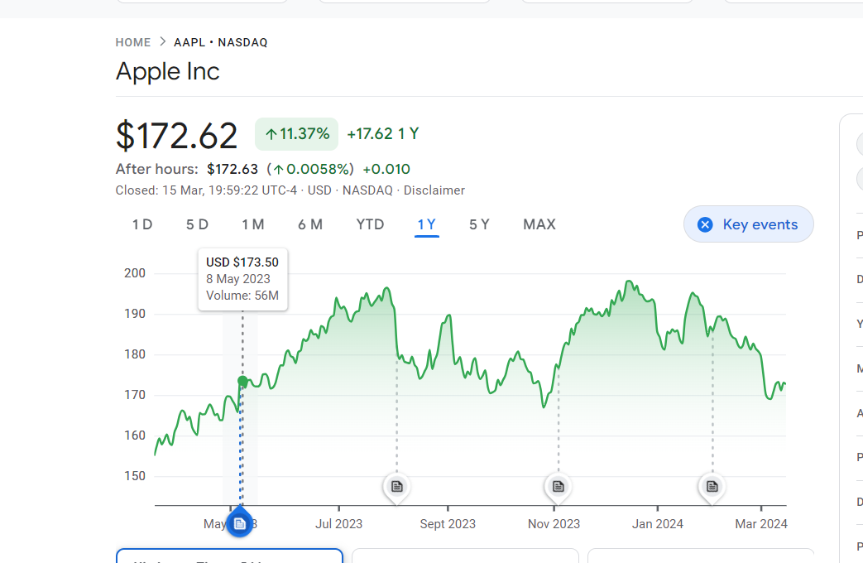

1. **Return on investment:**

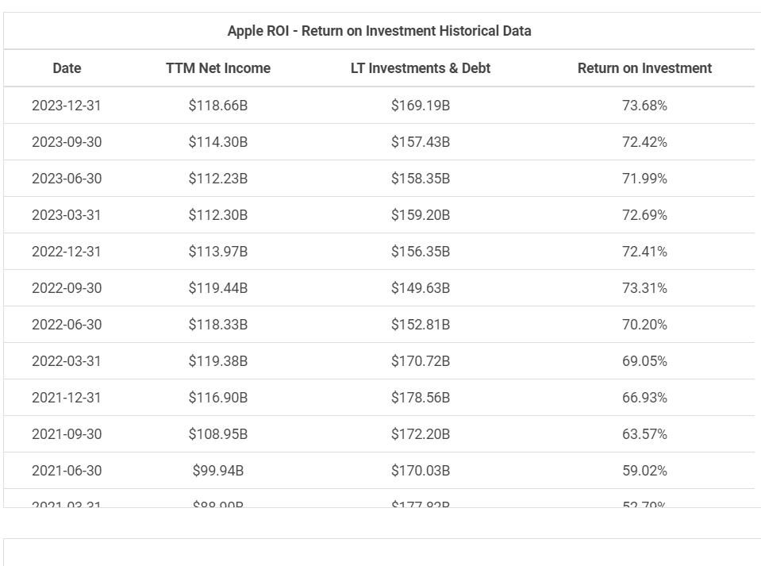

1. **Market share :**

Market share of Samsung smartphone sales worldwide 2007-2023. Apple claimed a 24.7 percent share of the market in the fourth quarter of 2023, an increase from the previous quarter. samsung long time competitor, apple, ranked first with a market share of 16.3 percent.

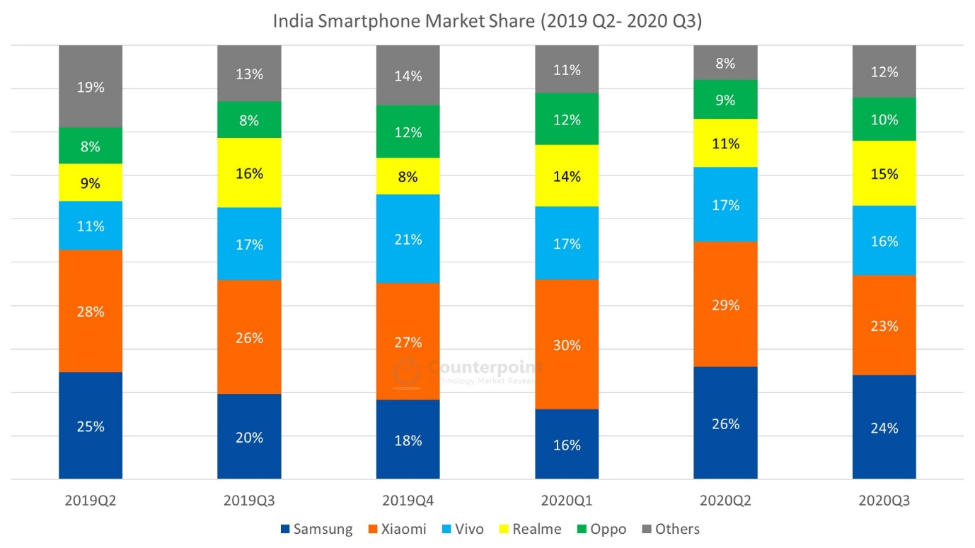

* **Analysing financial performance of**

**Consumer goods service company : ITC**

1. **Revenue growth:**

Organic growth reached 7.2%, with pricing of 7.5% and real internal growth (RIG) of -0.3%. Growth was broad-based across geographies and categories. Total reported sales were CHF 93.0 billion, a decrease of 1.5% (FY-2022: CHF 94.4 billion).

The underlying trading operating profit (UTOP) margin was 17.3%, increasing by 20 basis points on a reported basis and by 40 basis points in constant currency. The trading operating profit (TOP) margin was 15.6%, increasing by 160 basis points.

1. **Profit margin:**

FMCG major ITC India on Wednesday reported a net profit of Rs 656 crore for the quarter ended December 2023, which is up 4% year-on-year (YoY) from Rs 628 crore posted in the same quarter last year. Revenue from operations rose 8% YoY to Rs 4,584 crore in the reporting fourth quarter.

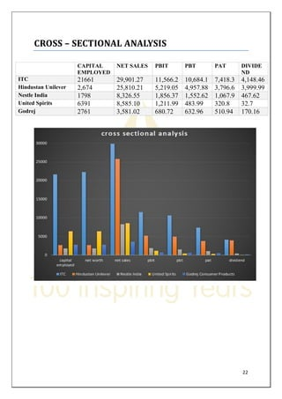

1. **Return on investment:**

ITC SA DRC's return on invested capital hit its 5-year low in December 2021 of 12.8%. ITC SA DRC's return on invested capital decreased in 2020 (13.2%, -3.8%) and 2021 (12.8%, -3.2%) and increased in 2019 (13.8%, +4.7%), 2022 (13.0%, +1.2%), and 2023 (13.6%, +4.8%).

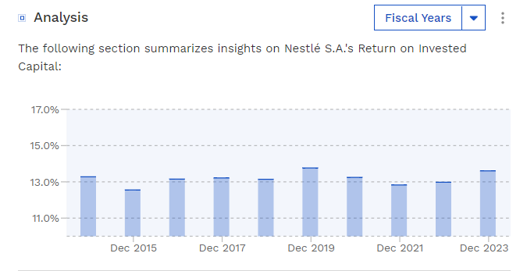

1. **Market share:**

As of March 2024 ITC has a market cap of $282.42 Billion. This makes ITC the world's 37th most valuable company by market cap according to our data.

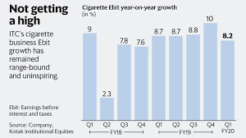

**ASSESSMENT OF SUSTAINABILITY**

COMPANY NAME :SAMSUNG

Samsung Electronics Co., Ltd. reported earnings results for the fourth quarter and full year ended December 31, 2023. For the fourth quarter, the company reported sales was KRW 67,780,000 million compared to KRW 70,460,000 million a year ago. Net income was KRW 6,020,000 million compared to KRW 23,500,000 million a year ago. Basic earnings per share from continuing operations was KRW 887 compared to KRW 3,460 a year ago.For the full year, sales was KRW 258,940,000 million compared to KRW 302,230,000 million a year ago. Net income was KRW million a year ago. Basic earnings per share from continuing operations was KRW 2,131 compared to KRW 8,057 a year ago.

**COMPANY NAME :ITC**

* ITC Limited reported earnings results for the first quarter ended June 30, 2023. For the first quarter, the company reported revenue was INR 193,617.8 million compared to INR 201,520 million a year ago. Net income was INR 51,049.3 million compared to INR 43,897.6 million a year ago. ITC has implemented various initiatives to conserve natural resources and reduce its environmental footprint. This includes water harvesting and conservation, energy efficiency measures, and waste minimization efforts across its manufacturing facilities and supply chain.
* **Renewable Energy**: The company has been investing in renewable energy sources such as wind and solar power to reduce its reliance on fossil fuels and mitigate greenhouse gas emissions. ITC has set targets to increase its share of renewable energy consumption.
* **Sustainable Agriculture**: Through its e-Choupal initiative, ITC promotes sustainable agricultural practices among farmers, including organic farming techniques, crop diversification, and water conservation methods

**CONCLUSION**

1)Technology company : **SAMSUNG**

Samsung is a global conglomerate that has established itself as a leader in the consumer electronics industry and beyond. The company's success can be attributed to several key factors:

1. **Innovation**: Samsung is known for its relentless pursuit of innovation, constantly pushing the boundaries of technology and introducing groundbreaking products and solutions.
2. **Diversified Portfolio**: With a diverse portfolio spanning smartphones, televisions, home appliances, semiconductors, and more, Samsung has built a strong presence in multiple sectors, mitigating risks and capitalizing on various market opportunities.
3. **Global Presence**: Samsung's extensive global footprint and distribution network enable it to reach customers in virtually every corner of the world, establishing a strong brand presence and market share across diverse markets and regions.
4. **Quality and Reliability**: Samsung products are synonymous with quality and reliability, earning the trust and loyalty of millions of consumers worldwide.
5. **Commitment to Sustainability**: Samsung recognizes the importance of sustainability and has implemented initiatives to minimize its environmental impact, promote social responsibility, and uphold ethical business practices.

**2) Consumer goods sector : ITC**

ITC Limited stands as a diversified conglomerate that has successfully established itself as a leader in various sectors, particularly in India. The company's success can be attributed to several key factors:

1. **Market Leadership**: ITC holds market leadership positions in several sectors, including cigarettes, FMCG (Fast Moving Consumer Goods), agribusiness, hotels, and packaging, among others. Its strong brand presence and extensive distribution network contribute to its market dominance in these segments.
2. **Diversified Portfolio**: With a diverse portfolio of products and services, ITC has effectively mitigated risks and capitalized on opportunities across different industries. This diversification strategy has helped the company achieve consistent growth and resilience in the face of market fluctuations.
3. **Sustainability Initiatives**: ITC is committed to sustainability and social responsibility. Through initiatives like the e-Choupal program, sustainable agriculture practices, renewable energy adoption, and community development projects, the company actively contributes to environmental conservation and social welfare.

**NAME: N. ANIL KUMAR**

**COLLEGE: Dr. Lankapalli Bullayya College.**